Skylar Wurster

CSE 5544 Data Visualization

Professor Jian Chen

March 9th, 2019

Assignment 4

The sampling resolution shift does show interesting features – both in the data and from a visualization standpoint. At very low resolution, such as a 5 by 5 grid, not much information is gained for a user. As we move the resolution up, there becomes a point where no more information is illuminated for the user. We see this diminishing return sometime after 20x20 grid size for the resolution. At this point, there is a clear ring of small magnitudes, and a raw visualization for the data is clear. Of course, this might overlook outliers, but that would probably require an algorithm to bring that to the attention of the user.

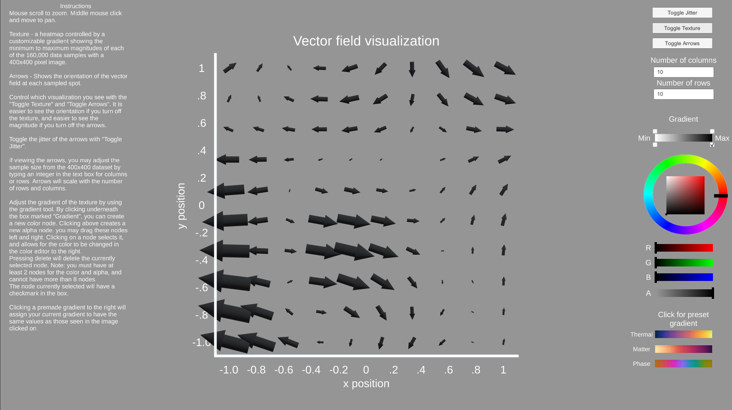

Above is a picture of the visualization with a 10x10 square grid sampled from the 400 by 400 download. We get a rough idea about where maxima and minima are, but no specifics. We also get a very rough shape of the actual vector field, but would be hard-pressed to trace an actual particle going through this field.

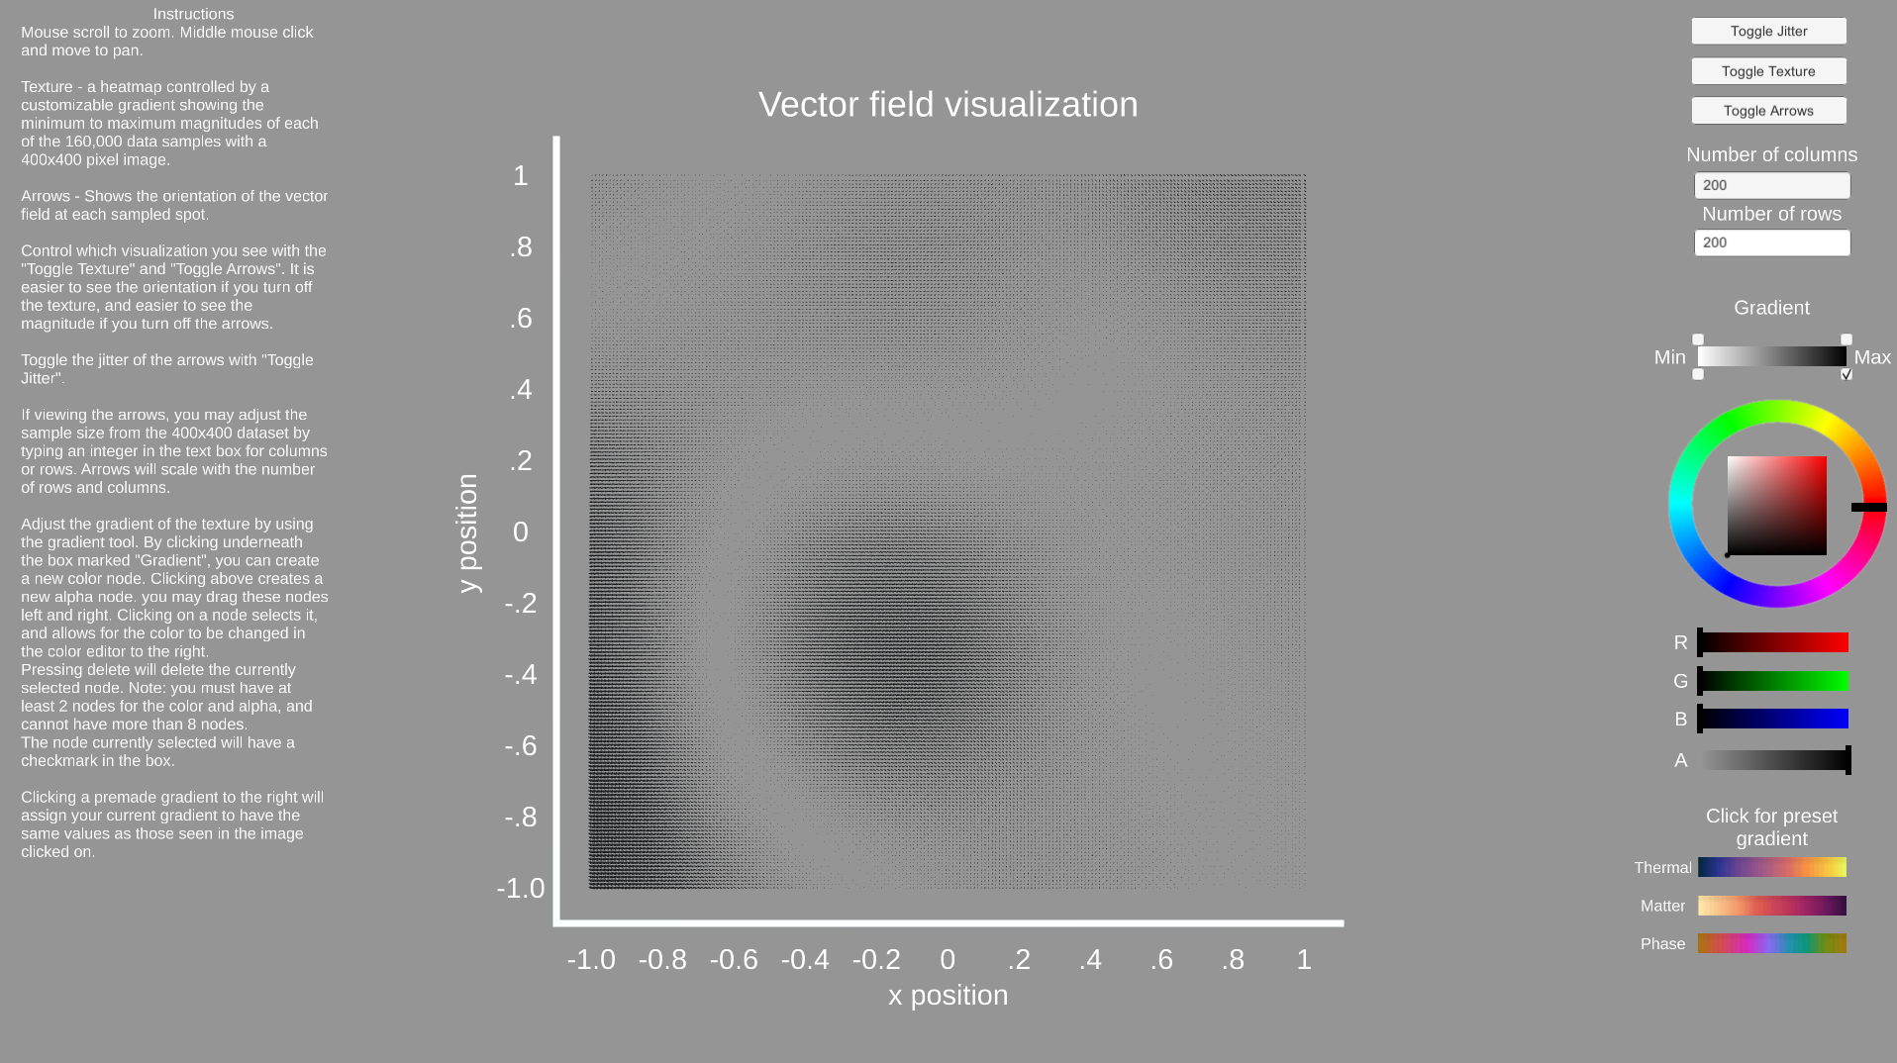

At 200x200, we can no longer make out individual directions, but can see where the magnitude is higher based on the perceived density.

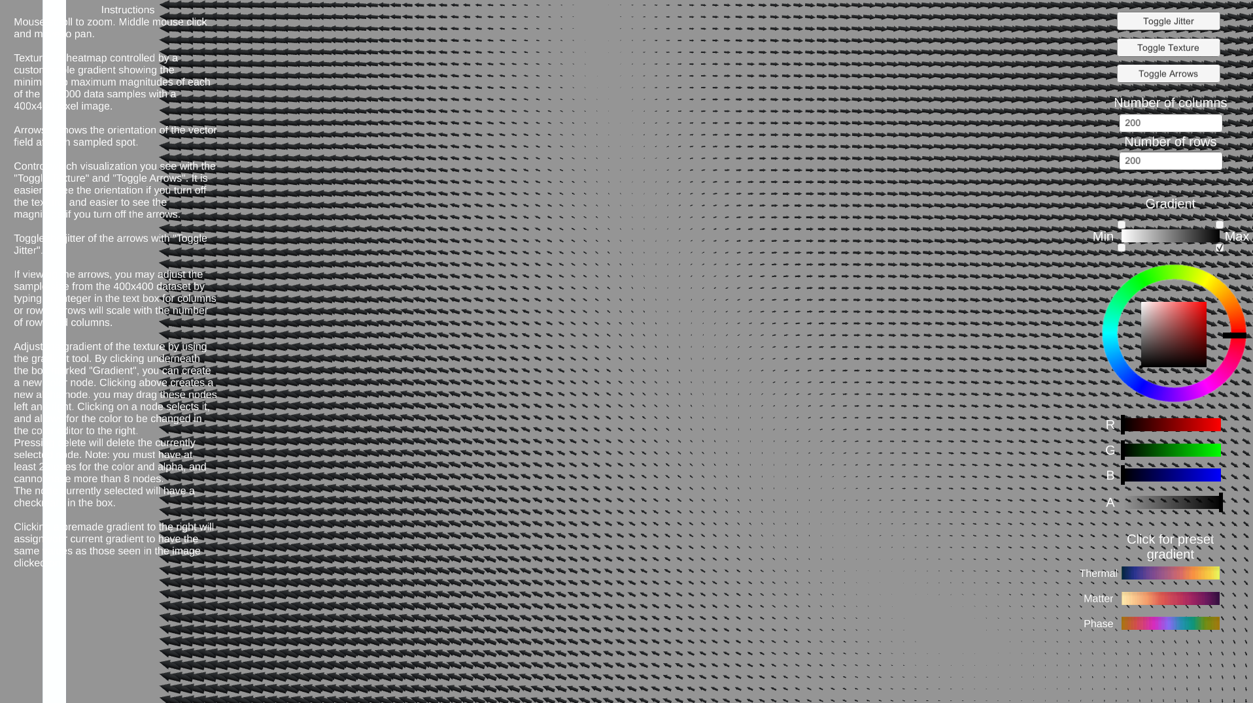

We may also zoom and pan in this view to get a better look at each point in space, but the direction is difficult to see.

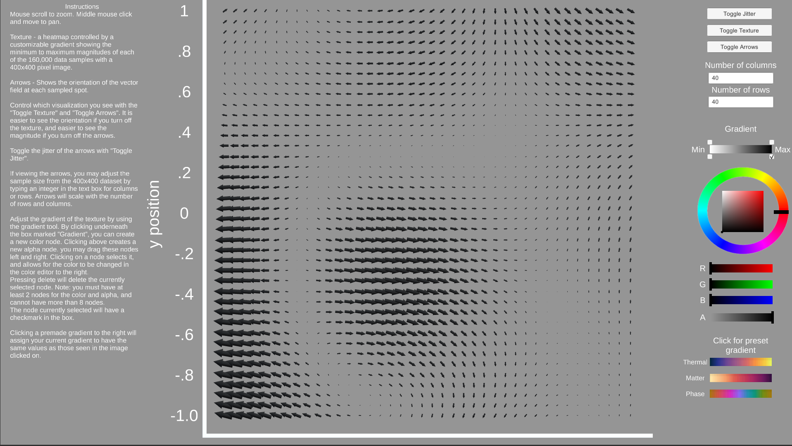

At 40 by 40, we get a very clear view of the direction and magnitude of the vector field and can make out features in the data.

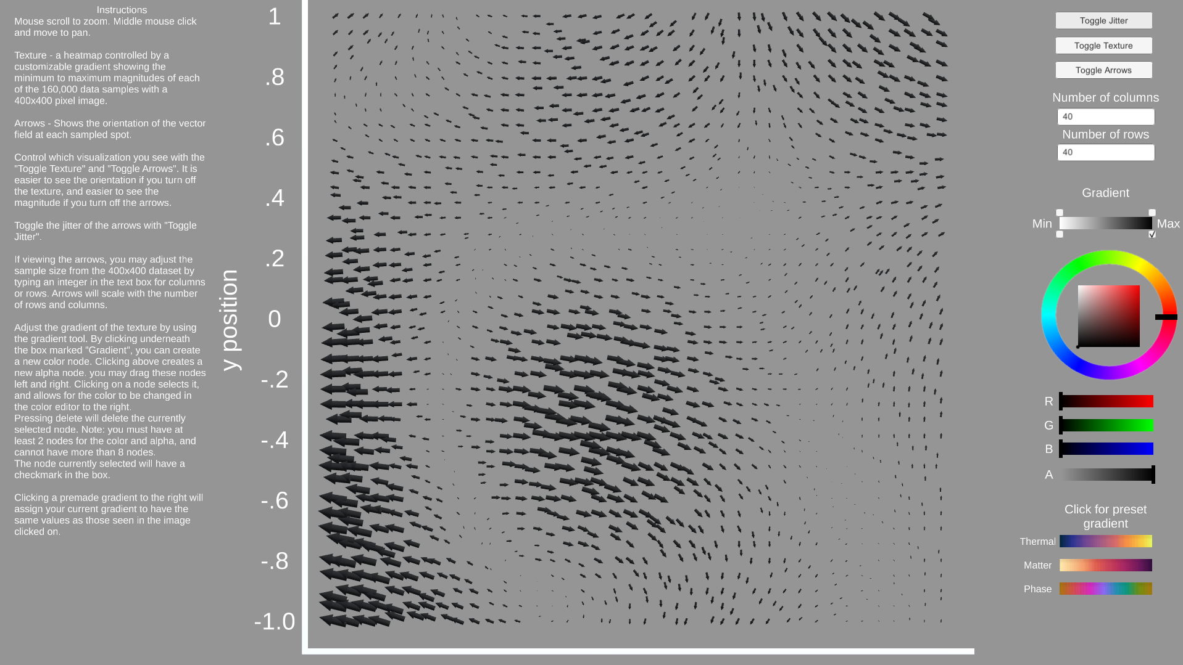

With jitter enabled, the sampling feels more organic. Since the spacing isn’t uniform, as above, it is easier to make out the direction of the arrows in an overview setting. Since the values are interpolated when in between multiple points, this isn’t the best visualization for diving deep and getting numerical values unless there is no way to measure for it. We also see the same features as before – a ring with low magnitude and high magnitude in the center of that ring, and to the left of that ring.

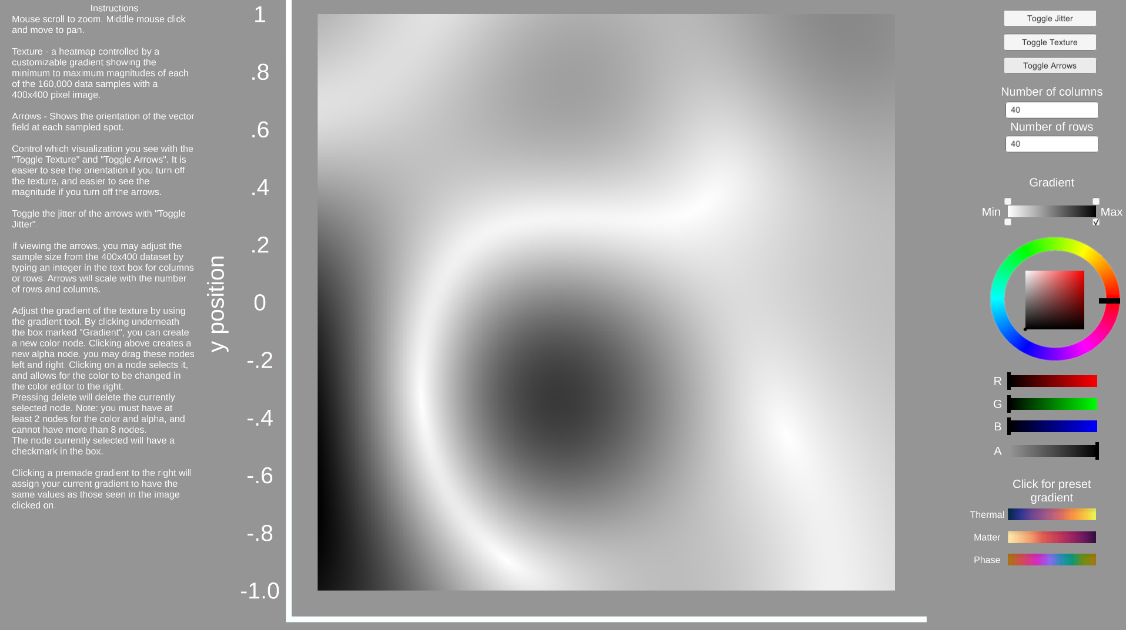

As another useful visualization tool, a texture map was created to visualize just the magnitudes. To isolate small changes in the magnitude, a color map can be used and customized. There are several templates to chose from including Thermal, Matter, and Phase.

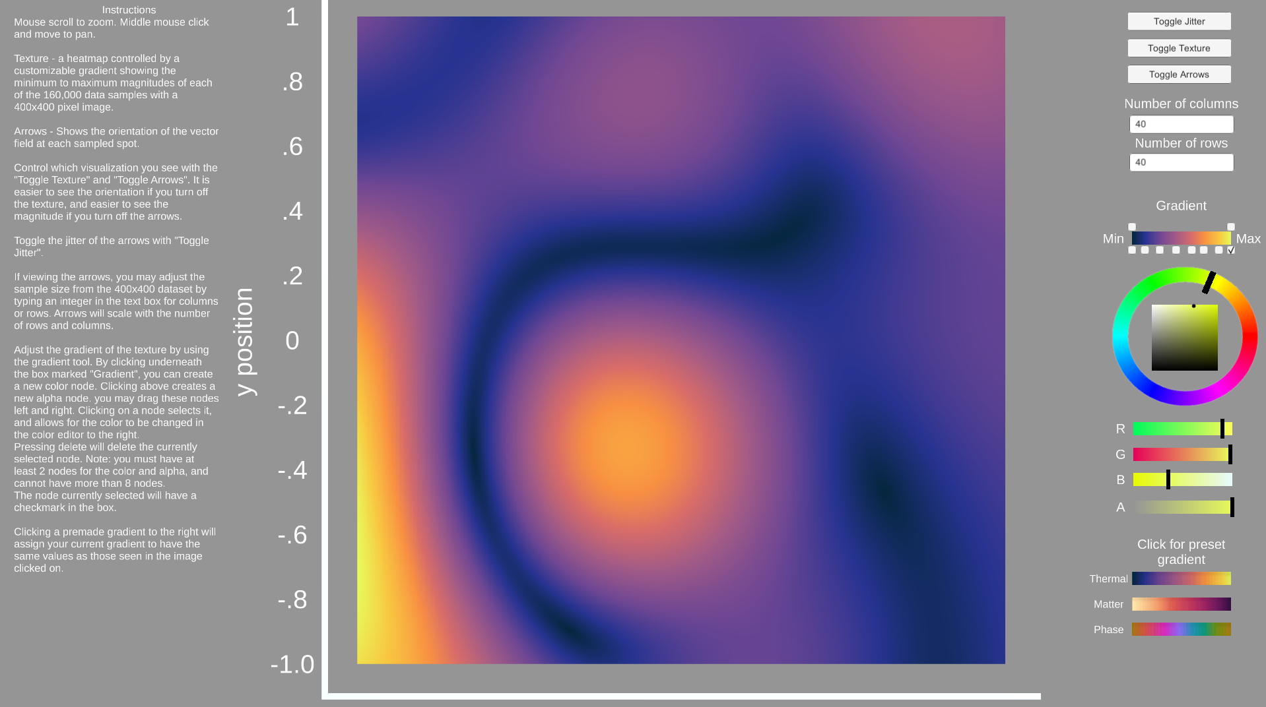

Here is an example of the Thermal color map. We can use this to see the clear maxima toward the left side and in the center of the ring. We also see the very clear minima ring here, and the gradient makes it simple to see the relative magnitudes. The gradient can be adjusted by moving the dots below the bar titled “gradient” on the right side. Bringing these dots closer can make small changes easier to see on the texture.